Website Development Project MCOMD2WDP

Group 1 Project Document

Nathan Shuttleworth, David Filipiak, Harry Davidson, Jordan Carpenter, Michael Adelodun, Christopher Kerr

Contents

Planning Review and Reflection 2

Wireframes 4

Information Architecture 8

Website Creation 9

Decisions and Justification 9

Testing 10

Project Review 11

Conduct 11

Learning 11

Improvements 11

Ethical and Legal Issues 12

Analysis of Fulfillment of Clients Requirements 13

Individual Evidence of Roles Fulfilled 14

References 15

# Planning Review and Reflection

As a whole, we believe that all of the features outlined in the initial presentation are realistic and achievable in the time frame. We do not think that the features that we plan to implement are overly complex and out of the scope of our abilities. We want to start with the most important parts, which is the base content and styling to see how our ideas look like, and then continue with the client-side functionality and dynamic web-page creation, which are in our opinions more complicated and less essential parts of the web site. The feedback that we received from the clients was very positive, they also had confidence in us being able to deliver what was planned. The following table details the features, a small description and changes we are going to make in light of the feedback and hindsight.:

|  |  |  |  |
| --- | --- | --- | --- |
| **Feature** | **Description** | **Changes for the final product** | **Justification of changes** |
| Virtual walk through | Images of the building that you click through to simulate moving around. | Instead, we will use a VR implementation | This will be used as is more interactive and will allow us to model the interior more convincingly. |
| Virtual galleries | Slideshow of images that can auto-scroll and have controls to select which image to view | None |  |
| Interactive map | Floorplan of the building, where each room is a button that you can click on to view more information about it. | Based more on floorplan layout than a side view | Not a full change but more a refinement of how the feature will be implemented. |
| Contact details page | Page showing address and contact phone numbers/emails for the building, and an embedded Google maps to show where the building is | A contact form is to also be included, so that users can enter their email and a message they want to give. This is stored on the database. | Easier access for the users to communicate, directly through the website. |
| Building construction time lapse | An image gallery showing the building being constructed, each image is timestamped to show progress at a certain date. | none |  |
| Location based AR | Not originally included in the plan. | If the user visits the correct part of the site whilst they are in the new building, they will be presented with new information. | Proof of concept for a more advanced system for helping users find their way around the building that could be implemented later. |
| Articles panel | A panel with the most important CCCU pages on the right-hand side of the screen | none |  |

## Wireframes

For the most part, the wireframes for the website are unchanged. Some pages did not have wireframes created, this has been rectified.

At the top of every page, there is the menu containing links to switch between pages. The menu adheres to the color theme of blue, white, red and grey. On the right of the menu, there is a search bar with a search button, which is unfortunately not functional due to team issues. On the right-hand side of every page, there is a list of articles that link to different web sites, but mainly original CCCU ones, such as the main CCCU home page, or news page. However, the first article is link to page with sources to images and information we used on our web site. We have decided to put it to the articles section, and not in the menu, because we think it is not a ‘menu-suitable’ page but is still important. In the articles panel, it fits with other links while still being noticeable and available for the web site visitors.

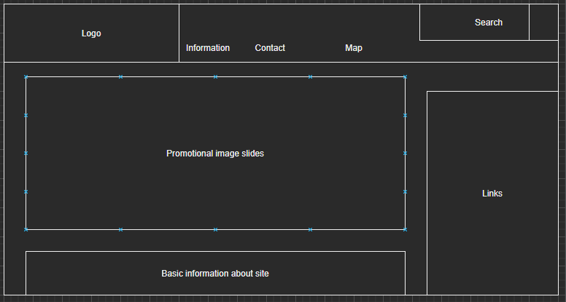

Figure 1- Landing/main page wireframe

The main feature of the main page is the image gallery. We have decided to go with three separate images: main image and two secondary images, which are smaller and more transparent. We went for this design because it looks quite good and is somewhat different from a typical image slideshow. The gallery is also very easy to maintain because the image generation is written in php and uses a MySQL database. The image locations are retrieved dynamically from the database and used to create the image objects in html. The only tricky thing for the gallery to look clean is that all images should have the same aspect ratio. The images are switched using two arrows on right and left from the main image, which is quite intuitive.

The second important part of the main page is the information it provides. The information about the Verena Holmes building is also retrieved from a database, making it very easy to change the text. Because the php writes the text from the database directly into the html, it is possible to include additional html tags within the database text to customize the output.

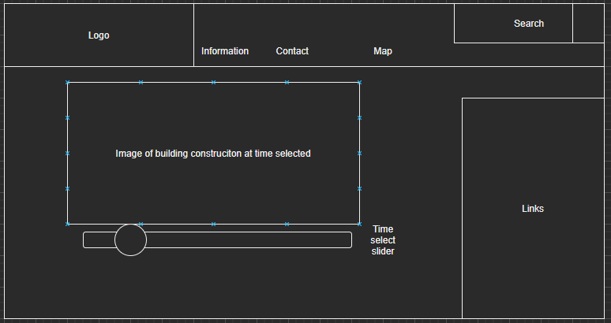

Figure 2- Image gallery and time-lapse page wireframe

For the construction timeline, we agreed on an image slide show that is manipulated using a slider. The slider is designed to match the theme of the webpage and it switches the images and also their descriptions. The images and descriptions are dynamically retrieved from a database in a similar fashion to the images in the image gallery on the main page, and therefore the construction slideshow is quite customizable and easy to maintain. We think that a slider is a suitable control in this scenario because it can represent a timeline showing the progress of the construction of Verena Holmes building. As with the image gallery, we recommend having the images the same aspect ratio, so that the whole slideshow looks stable and does not jump up and down on the screen.

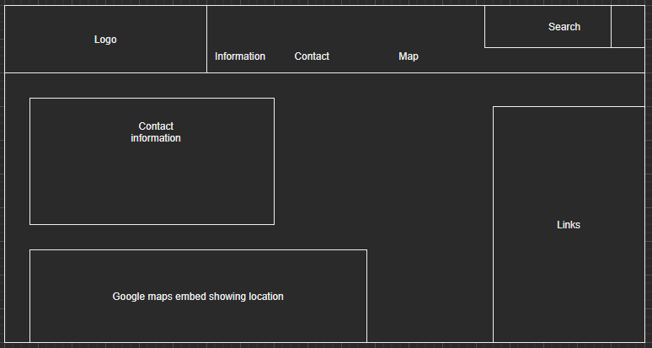

Figure 3- Contact page wireframe

The contact page has three significant features: The list of contacts, the embedded Google map and the contact form. The contacts list information come from a database similarly to the information on the main page and can be customized with html tags inserted in the text. We decided for a light grey look for the contacts, which makes it look quite clean. Initially, we thought to put the embedded Google map below the contacts list, but then we decided to put it to the right, because there was a lot of empty space. The map is meant to show the location of the Verena Holmes building, and therefore cannot be changed, as addresses do not usually change. The map has responsive layout, which is obvious when the screen has less than 800px, it will change the position to beneath the contacts.

Below the contacts list and the map, we decided to add a contact form, where the web page visitors can ask questions using their emails, and it is then sent to the database for further processing. The form has also input validation and does not let the users input empty fields, and requires ‘@’ sign to be entered in the email field. The form is styled similarly to the contacts, with light grey background making it look nice and clear.

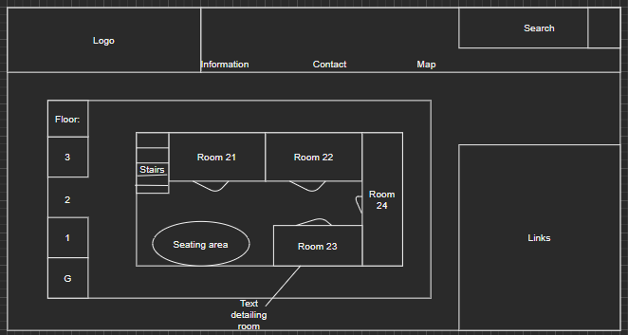

Figure 4- Interactive map wireframe

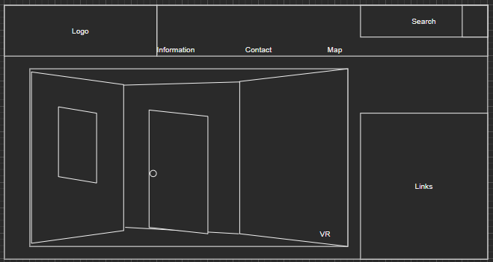

Figure 5- VR Virtual Walkthrough wireframe

## Information Architecture

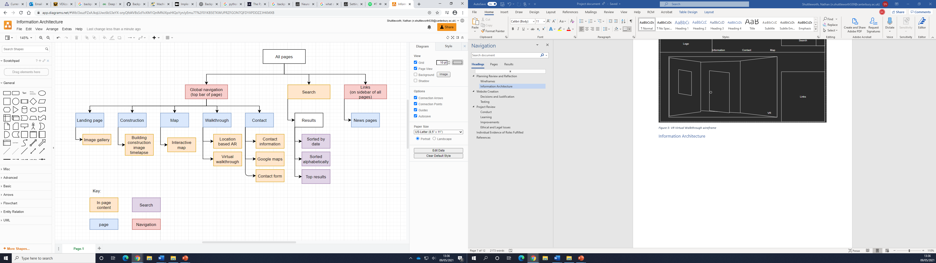

# Website Creation

Website link: <https://www.df239.webhosting.canterbury.ac.uk/assignment/mainPage.php>

## Decisions and Justification

|  |  |  |
| --- | --- | --- |
| Date of Dilemma | Dilemma | Description |
| 31/3 | Website hosting | We decided to use the University webhosting, as it was free and we are all familiar with it. David created a new user so that we could access certain parts of his webhosting that were relevant to the website. We used the FTP client FileZilla to access it. |
| 14/4 | Issues with Iframe implementation | Initially when using Iframe to embed a Google Maps page into out contact page, the Iframe was blocked due to security reasons. This was fixed a week or so later by setting the website to be ‘secure’, the address would now be https rather than http. |
| 22/4 | VR implementation | When creating the VR walkthrough, we found that it could only be accessed in full screen if you visit it’s URL, and so to fix this we used Iframe to embed it into the page, with a button offering a full screen option. |
| 29/4 | Searching | It had always been the plan to implement a working search bar and results system, however due to not all team members working at the same rate, we ran out of time to properly implement this as it was too complicated to do in the time remaining. |
| 29/4 | Interactive Map | As with the searching, we ran out of time to fully implement this due to differences in workload between team members. |
| 6/5 | Website Accessibility | Using the websites from Level Access(2021) and Toptal (2021), we found out that numerous improvements could be made to the website with regards to accessibility. These included changing the stated language for the pages, giving images the ‘alt’ tag, and using Semantic elements, amongst others.  Using the level access website, we aimed to reach a minimum of 85% score for accessibility (100% being most and 0% not at all) |
| 6/5 | Referencing | The website contains some elements from outside sources, primarily images. Our way to deal with referencing them all without interrupting the design of the website is to create a new page that includes references to where we got all of the content. |

## Testing

Usability testing is when an external group of people interact with the website and using their reactions to test the product. This can be done by seeing their reactions or by their behaviors. Behaviors can be monitored by also including things to monitor how users interact with the website. The feedback gotten can be used to make a more enjoyable user experience. We used the usability testing to make the layout of the website intuitive and easy to use. Reactions to usability were used to change the prototype to the final layout of the website in concordance with the results found from the testing.

As a team developing the website, we all were testing it as we went along and gave feedback to each other. Some members would see design flaws as they interacted with the websites and pointed these out. Such things as them testing the website on their phone to see how it would interact and scale. Others would just test and see if all the links would work which may have gone overlooked. This testing helped making sure everything was working as intended.

One of the features on the website is a virtual reality layout of the building. We tested this by giving the website to someone with a VR headset. They then gave us feedback on the feature, a majority being positive. This was then used to improve the VR experience of the website.

Unit testing was done once a feature was finally developed and still in the development cycle. We would write down the desired output we would wish for with the input that we were going to test. After, we would then put the input on the site and see the results. An example is the “ask us anything” part on the contact page. We would make sure that the written fields would correctly be submitted as intended.

Once the website was complete, we also used functionality testing. This was to make sure each portion of the website worked in the final product. We could use results from the unit testing during development to make sure it still worked as intended once adding in other elements. This also could be used to test interactions between parts of the website which may not have been possible during the development of it.

Since we were using the agile software development life cycle, we would also conduct regression testing at the end of each iteration. This was done to make sure that anything that was added during the current iteration did not interfere or disturb anything already included in the website. We would have to conduct our previous tests again at the end of each iteration and made sure all the results were the same. If they were not, we would have to re-evaluate what we had done in the iteration and how we could reimplement what we have done to be able to coincide with the previous parts of the website.

# Project Review

## Conduct

The conduct of this group for this project could have been better. For the most part, only Nathan and David engaged with the development of the website, and also did more than everyone else with regards to the presentation and project documentation. Other members of the team stated that they would partake, but either never did or did very minor tasks. This is why the website is well polished in some areas and missing content in others. Everyone was assigned jobs to do but because not everyone did them it means that website does not have the search and interactive map features. There was also the case where one group member did not have any contact with the rest of the group, despite our best efforts to do so.

## Learning

Throughout this project, we have learned many things and improved regarding both our knowledge relating to websites and their development, and also transferrable skills and experience to do with working on a project as a team. Many of us found learning about PHP and databases use in websites new, whilst most of us had prior web experience this was new to a lot of us.

Another way in which we learned was with regards to working on a project in a team. This project helped us develop how to allocate work for team members, and what to do when you have team members that you cannot communicate with. A different thing we learned was how to manage your own workload when different members are putting in different amounts of work.

## Improvements

Although the project went well, particularly in terms of the quality of the product created, there are several ways that the process could be improve if we were to undertake this project again. The first improvement would be to allocate work to each member more clearly, and to stress the importance of this work. Whilst we held weekly meetings and planned out which member would do what, not everyone did what they were meant to and so others had to take up other work on top of their own. If the importance and the way in which everything fitted together had been more clearly stressed, I think that things would have been done more smoothly.

Another improvement that could be made is to be more familiar with some of the concepts and tools we worked with before beginning planning, let alone development on the website. This is an explanation as to why some content, such as the VR walkthrough and inclusion of the location-based AR were later changes to the project. Whilst it is positive that we learned many new things throughout this project, being more competent with things such as PHP and A frame VR from the outset would have been beneficial as opposed to having to learn them whilst creating the website. This also goes for things such as accessibility. Whilst we were all aware of how a website (or any software for that matter) should be designed to be as accessible to everyone, regardless of ability, we did not have a full idea in how to optimize a website in this regard until very late in the project.

Another key area in which improvements could be made is in regard to the websites hosting and version control. We used the Universities’ web hosting for our site, and because this is linked to each user, an FTP client had to be used to upload files. This meant that to update a file, you would have to download the existing one from the hosting, make the required changes then re-upload it and overwrite the original. This was time consuming, and also did not allow versions to be kept track of very well. If instead a version control software such as Git had been used, we would have been able to see who was making what changes and be able to roll back if needed.

A minor change that could also be made is to change the URL of the website, currently it is quite long and unwieldy, it would not be easy to remember and type into a search bar.

Whilst a separate webpage was included as part of the website was used to keep track of references and attribution for things such as images, a more effective way to reference work would be to potentially include lightboxes for images, and when you click on them the image is enlarged and its source is shown.

The A-frame VR could have been improved with the implementation of a physics engine, so that when the user ‘walks’ into a wall, they wouldn’t be able to pass through like is currently the case.

## Ethical and Legal Issues

The primary issue relating to this project was to do with copyright, licensing and referencing. Since this is a proof-of-concept website, some of the images used are not original nor actually of building 2. In particular, the images used in the construction time lapse are taken from a YouTube video displaying a time lapse of the construction of a building in the USA. The images were simply screenshotted from the video. It was only later that we remembered that content needed to be appropriately referenced. Putting reference text all over the website would have inhibited it design and the user experience, and so instead the solution we came to was to include a new page that had references for all the content, which could be accessed by the user if they desired to, without spoiling how the website looks.

Another important issue relating to legality and ethics is the storage of user data. On the websites contact page, there is a form that lets the user enter their email address and a query for the representatives of the building. The email address and message are then stored in a database which is hosted online like the website. Whilst this is a very streamlined way of allowing the users to make contact, it is very insecure. Firstly, there is no prompting for the user about GDPR or agreeing to have their personal data stored. Also, the stored email addresses are not hashed or have any kind of encryption, meaning that if the database were to be hacked, the user’s sensitive personal data will be compromised.

An additional ethical issue is how accessible the website is, if differently abled people such as those who are hard sighted cannot use the website, that can be discriminatory. Using the Level Access tool, we intended to reach a minimum of 85% accessibility for each page, which was achieved. Most of the remaining issues are general ones which in the context of the website are not a problem.

## Analysis of Fulfillment of Clients Requirements

As a whole, we believe that we have done a good job at meeting the needs of the clients. They asked for a website that would promote and ‘provide information about the new building’ (Assignment Brief). Some of the suggestions for content included a virtual walkthrough, web-based AR, virtual galleries, and communication tools. Our website features all of these, as well as other similar content that fits with this theme and ideas. In our meetings with the clients, we learned that they would like the aesthetics to be similar to but not identical to that of the existing CCCU websites, which we have done.

There are also requirements that, whilst not explicitly stated, can be inferred from the clients brief. This includes the need for the website to be accessible to a large range of people.

One area in which we have not fulfilled the clients needs as much as we could have done is optimizing the websites to be easy to maintain and by people who are not trained in website development. Currently, there is no way to edit the site without having HTML and CCS knowledge.

# Individual Evidence of Roles Fulfilled

|  |  |
| --- | --- |
| **Team Member** | **Role fulfilled/ Jobs done** |
| David Filipiak | Everything to do with databases, php and JavaScript; page-specific CSS and html such as the contact form, image gallery on main page and time-lapse; the references page. Write about wireframes on the document. |
| Nathan Shuttleworth | VR and AR development and its webpage, assisted with time-lapse and did much of the project documentation as well as optimizing web pages with regards to accessibility. |
| Jordan Carpenter | Some basic general CSS |
| Michael Adelodun | Found information text to put on the main/information page. |
| Harry Davidson | Wrote about testing in the document |
| Christopher Kerr | None |

# References

Level Access, 2021. Web Accessibility - <https://www.webaccessibility.com/> (Accessed 6/5/2021)

Toptal, 2021. Toptal Colorblind Webpage Filter - <https://www.toptal.com/designers/colorfilter> (Accessed 6/5/2021)

Turner, Scott and Ward, Gareth. MCOM2WDP Web Development Project Assignment 2 Brief - <https://learn.canterbury.ac.uk/bbcswebdav/pid-2560505-dt-content-rid-4285630_1/courses/S20MCOMD2WDP/Assignment_2_Brief___WDP_2020_21%281%29.pdf> (Accessed numerous times from beginning to end of project)

References for information included in the website are here: <https://www.df239.webhosting.canterbury.ac.uk/assignment/references.php>